Nottingham Trent University

School of Science and Technology

ASSISTANT SYSTEM FOR SENIOR

by

GEE DING YONG

in

2019

Project report in part fulfilment

of the requirements for the degree of

Bachelor of Science with Honours

in

Software Engineering

I hereby declare that I am the sole author of this report. I authorize the Nottingham Trent University to lend this report to other institutions or individuals for the purpose of scholarly research.

I also authorize the Nottingham Trent University to reproduce this report by photocopying or by other means, in total or in part, at the request of other institutions or individuals for the purpose of scholarly research.

Signature

GEE DING YONG

Abstract

# Nowadays, forgetfulness is a common complaint among many of people as they are getting older. Most of the seniors are having problem of remembers things such as medication, appointment or placement of objects. In addition, forgetfulness makes most of the seniors forget to keep track of their health condition.

The main objective of this project to help the seniors to solve all these problem in their daily lives. With this application, seniors able to reminders things. Besides, seniors able to keep track of their health condition. Furthermore, seniors able to keep contact with their doctor so that they do not miss any of the appointment to maintain their health. This application makes the seniors more convenient in the future.

Some existing application is referenced and compared to generate new ideas to implement a user-friendly assistant system for seniors. Hence, applications are being reviewed, the strengths and weakness of the particular website are listed out to provide clear view.

In conclusion, the main concern of this project is to develop a user-friendly and efficient assistant system to help seniors in their daily lives. To achieve that, researching, planning, designing, testing, and lastly evaluation should be done properly within the time frame.

Acknowledgements

The production of this project involves many advisement from a number of people. Hence, we would like to grab this golden opportunity to express our appreciation to those who have given their help, guidance and encouragement to us during the development process.

First, I would like to express my special thanks of gratitude to my supervisor, Mr Koong Kok Leong, who gave me the golden opportunity to do this project and gave endless support, generate ideas and advices throughout the whole implementing process. I would also like to thank my classmates who also helped me in doing a lot of research and I came to know about so many new things.

Apart from the efforts, the success of any project depends largely on the encouragement and guidelines of many others. I would like to take this opportunity to express our gratitude to the people who have been instrumental in the successful completion of this assignment.

Table of Contents

Abstract ii

Acknowledgements iii

Table of Contents iv

List of Figures vi

List of Tables vii

CHAPTER 1 1

Introduction 1

1.1 Introduction 1

1.2 Prepare Your Report 2

1.3 Heading Styles 3

1.3.1 Numbering of Headings 3

1.4 Document Paragraphs 3

1.4.1 First Paragraph Following a Heading 3

CHAPTER 2 4

CONTEXT 4

2.1 Introduction 4

2.2 Insert Pictures 4

2.3 Insert Tables 5

CHAPTER 3 6

New Ideas 6

3.1 Introduction 6

CHAPTER 4 8

Software/Hardware Development Error! Bookmark not defined.

4.1 Introduction 8

CHAPTER 5 10

RESULTS / DISCUSSION 10

5.1 Introduction 10

CHAPTER 6 11

CONCLUSIONS / FUTURE WORK 11

6.1 Introduction 11

ReferenceS 12

Bibliography 13

Appendix A 14

**Note:** To insert TOC here follow the instruction below. You may also right click on the above text and use “Update Field” to update the TOC.

Insert > Reference > Index and Tables … > Table of Contents

List of Figures

Figure 1: Microsoft XP 5

**Note:** To insert List of Figures here follow the instruction below. You may also right click on the above text and use “Update Field” to update the list of figures.

Insert > Reference > Index and Tables … > Table of Figures > Caption Label => Figure

List of Tables

Table 1: Microsoft Office 2003. 5

**Note:** To insert List of Tables here follow the instruction below. You may also right click on the above text and use “Update Field” to update the list of tables.

Insert > Reference > Index and Tables … > Table of Figures > Caption Label => Table



Introduction

This chapter is the introduction for the entire project. The content of this chapter is about the project background, the aim and objective of the project, overview of the project and the project scope.

## 1.1 Project Background

Nowadays, forgetfulness is a common complaint among many of people as they are getting older (Smith, 2018).Most of the seniors are having problem of remembers things such as medication, appointment or placement of objects. This problem will causes a serious consequence for the seniors themselves or other innocent people. For example, seniors’ health condition will getting serious if they are not take medicine on time. If this situation continues, it may cause the elderly to be in danger. Besides, most of the seniors nowadays are suffering from dementia. They always forgot the placement of object. It may cause the seniors or the guardian of the seniors consume a lot of time to search the object.

In addition, forgetfulness makes most of the seniors forget to keep track of their health condition. It is also very difficult for some of seniors to check their blood pressure and heart rate by using medical equipment because their movement are limited due to grow of age. However, those simple medical equipment have their limitations. They cannot keep track the calories burned daily and the sleep quality of the elders.

In order to help the seniors to solve all these problem in their daily lives, an Android application is planned to be developed. With this application, seniors able to reminders things. Besides, seniors able to keep track of their health condition. Furthermore, seniors able to keep contact with their doctor so that they do not miss any of the appointment to maintain their health. This application makes the seniors more convenient in the future.

## 1.2 Project Overview

Recently, there are many assistant system for seniors which exist in the world. The assistant system can help senior in different aspects such as health and others. Most of the assistant system for seniors are not perfect or limited and they cannot fully help seniors in daily lives. Most of the application nowadays are able to help people to keep track of their health condition and the information will be sync with their doctor. However, some of the application does not has this feature yet. The seniors get a lot advantages by using this feature but the main issues which is forgetfulness is not been solved. Most of the seniors are having this problem and it may causes the seniors in danger. The application nowadays cannot take care in both aspects which are health and memory.

So, an Android application called ‘SeniorAssistant’ is implemented to be an assistant system for senior to overcome their problems in daily lives. This assistant system can help senior in different aspects such as health, memory and others. This application helps seniors to keep track of their health condition every day but the condition is the seniors must wear a smartwatch on their wrist all the time. Besides, this application also helps seniors to remember things such as appointment. In order to make the seniors more convenience, voice recognition is implemented instead of using text command. There is a lot of functionality and they will be discussed more detail in further chapter.

As a conclusion, there is a lot of things that need to be improved so that an efficient application can be produced. Tis application will helps a lot in seniors’ daily lives and make their lives more convenience and relax.

## 1.3 Aim

The aim of this project is to design and develop an Android application to assist the senior citizen in their daily lives.

## 1.4 Objectives

* To research the functionalities of currently available application that related to this project by 8 October 2018
* To analyze the weakness and strength of the existing application by 15 October 2018
* To propose new ideas that improve the application and overcome the weakness of the existing application by 22 October 2018
* To design a user friendly application by 26 November 2018
* To implement an efficient Android application that achieves all the functional requirements by 5 April 2019
* To evaluate the developed application and ensure that the application is well-functioning by 19 April 2019
* To prepare documentation based on findings by 3 May 2019

## 1.5 Project Scope

The target user of this project is the senior citizen. Senior citizen is the main character that perform the functionality of this application. This project aims to help the senior citizen to remember things such as medication, appointment and others. This project involves technology such as smartwatch which is used by the seniors to measure the heart rate, step taken every day and others. Bluetooth is used to transfer and receives data between smartphone and smartwatch. Besides, voice recognition is used to make user more convenient when using this application.

## 1.6 Organization of Report

Organization of report is a short summary description for each chapters in this report.

Chapter 1 is basically the introduction of the report and system. In this chapter, it describes the background of the project and the overview of the entire project. Besides, the aim, objectives and the project scope has been clearly defined in this chapter.

Chapter 2 is the chapter which describes the literature review about this project. Some existing system is being researched to found out their strength and limitation. These system has been compared to generate new ideas to improve the system.

Chapter 3 is the list of the new idea that suitable for this project. Based on the literature review, some existing function can be enhanced to become better and new ideas which are technology or functionality can be added to produce a better assistant system for senior.

Chapter 4 is the chapter which describes the design phase of the project. It contains several diagrams that used to define the flow and the structure of the project. The example of the diagram are Context Diagram, DFD diagrams and others.

Chapter 5 is the chapter that describes the testing phase of the project. It contains test plan which includes the testing description of each function.

Last but not least, chapter 6 is the conclusion for this project. This chapter includes the summary of the result and future enhancement based on the limitations of this system. Besides, problem encountered and the action taken to solve the problem will be discussed in this chapter too. The content of references and appendix will be shown after this chapter.



CONTEXT

This chapter include a literature review in order to detail the historical details and also State-of-the-Art in the field of assistant system for seniors in daily lives. Besides, the review for the existing applications will been discussed in this chapter.

## 2.1 Historical Detail and State-of-the-Art

Before the technology is so developed, there are no applications or systems that are able to help seniors to solve the problems of remember things and keep track of their health in their daily lives. Most of the seniors are having problem of remember things such as medication, appointment and others. One of the ways to helps the seniors to solve this problem before the technology is so developed is the seniors keep track of the appointments and the events with a calendar or diary (Corr, 2019). Seniors need to record the appointment or event on the calendar or diary to keep reminding them. However, this method is not so efficient because the calendar or the diary will not trigger the memories of the seniors if the seniors are not look through the calendar and diary. Besides, there is another way that helps senior to remember things before the technology is so developed which is writing notes and putting it at an obvious spot in the house (Corr, 2019). It can act as a trigger for memories. However, both of these way are not so helpful for the seniors if the seniors have limitations in dexterity of writing.

Before the technology is so developed, the seniors need go to hospital or clinic to keep tracking their health. For example, the seniors go to hospital to measure their blood pressure, heart rate, blood sugar and others to make sure their health are in good condition. It is very inconvenience for the seniors because they need to travel a long distance to the hospital to do the simple body check. It is time consuming and it is difficult for some of the seniors which have limitation in mobility. Private doctor can be hired to solve these problems. Private doctor is the person who has experience in all area of medical fields and the patient is able to see the private doctor from the comfort of their own home in short time (Doctor, 2019). According the Push Doctor, the private doctor provide prescriptions, sick notes and referral letters for specialist treatment. Prescriptions cost £8, while a referral letter or sick note will costs £15. However, this method does not work well because the seniors have to pay expensive fee to hire a private doctor and not all the families have the economy to pay these expensive costs.

Today's technology is more and more developed, smartphone have also become a necessity in people's lives. The number of mobile users in 2019 is around 2.5 billion (statista, 2019). By using smartphone, people can do a lot of stuff such as mailing, shopping and others. There is a lot of existing applications or systems which able to help the seniors in daily lives. The existing applications has functionalities such as helps seniors to quickly request help when they need it with SOS feature, phone memo and others. Besides, there are some applications with device which able to help the seniors to keep track of their health such as blood pressure, heart rate and others. These only can be measured when the seniors wear the specific smartwatch. There are some existing applications are reviewed to detail the State-of-the-Art in this field so the new ideas can be proposed and the improvement can be made.

## 2.2 Review on Existing Application

### 2.2.1 Overview of “Personal Assistant”

Personal Assistant is an Android application which designed by VPIITSolution. Figure 1 shows the main page of this application. The design of this application is very simple. All the main functionality of this application is shown in the main page. The main functionalities of this application are appointment reminder, notes, diary, health manager, expenses and currency converter.

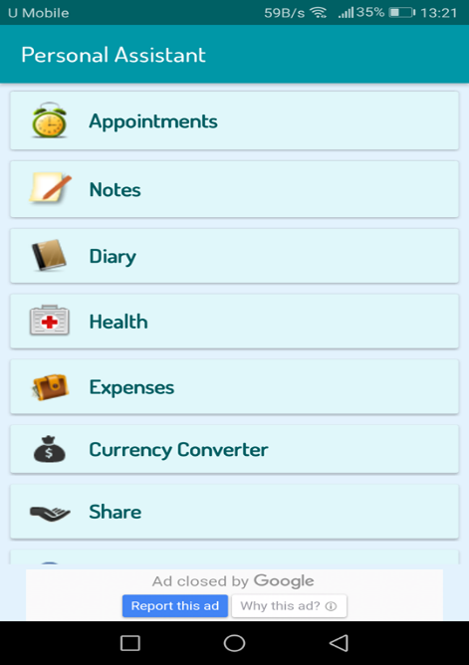

Figure 1 Main page of Personal Assistant

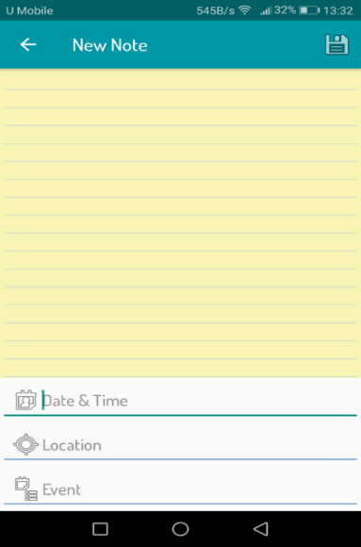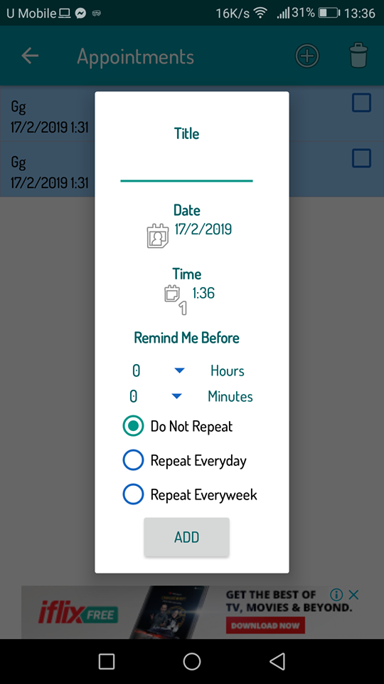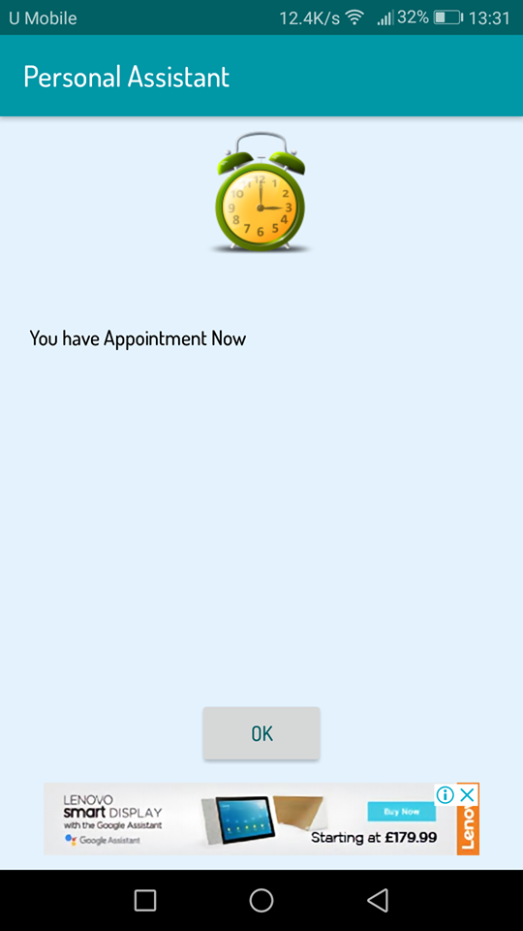Figure 2 shows the appointment reminder of this application. User need to set the title, date, time, frequency of reminder to add the new appointment reminder as shown as the first picture in Figure 1. When the current time matches the time which the user set, the smartphone will ringing with ringtone and show message as the second picture in Figure 2. The message is fixed by the system and the user cannot set the detail or description of the appointment.

Figure 2 Appointment Reminder

Figure 3 Note

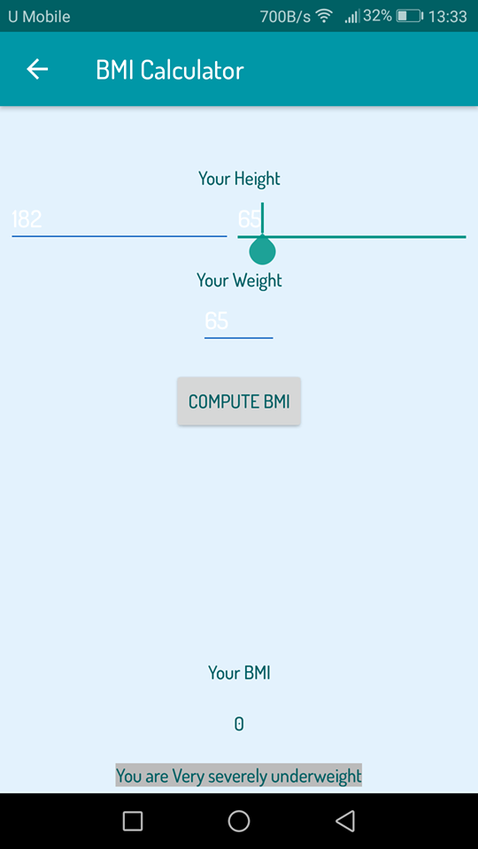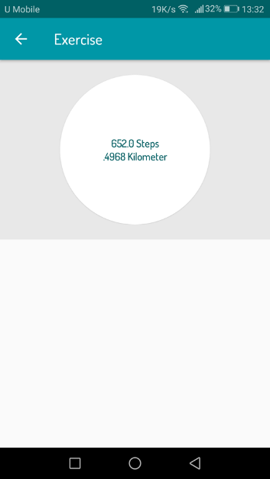Figure 3 shows the interface of the note function. User can write anything in this note. User able to set the date and time, location and event. User need to manual type in the date and time, location and event. The location will be set by using GPS. After complete fill in all these thing, click the save button on the right corner to save the note. The diary function of this application is almost similar with this. The only difference between both of these is just the diary function’s date had been set.

Figure 4 Health Manager

Figure 4 shows the health Manager of this application. This function consists of 3 sub-function which are BMI calculator, exercise which will record moving step and moving distance of the user and the calories chart. Users able to calculate their BMI by key in their weight and height with this BMI Calculator. Besides, the calories chart will shows several types of food with their calories.

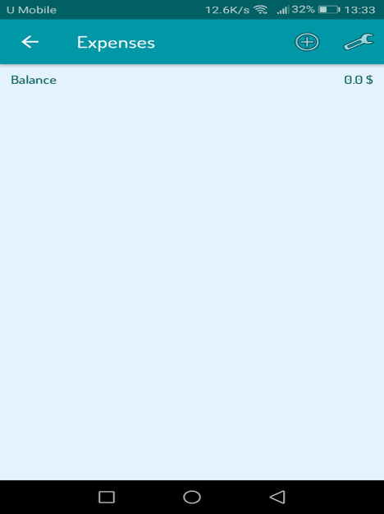

Figure 5 Expenses

Figure 5 shows the expenses function of this application. User able to record their daily expenses by using this function. The function is very simple. User just need to input the transaction details, amount of expenses and type of transaction either it is debit or credit to add a new transaction. The currency of the money of can be set by the user and the total balance will be shown on the right corner below the toolbar.

#### **2.2.1.1 Strengths and limitations of application**

|  |  |
| --- | --- |
| Strength of application | Limitation of application |
| 1. Clean and simple graphical user interface (GUI). | 1. Font becomes blur because some of font colour are similar with background colour. |
| 2. Contains multiple functionality that are useful to assist seniors in daily life. | 2. Voice recognition is not implemented. |
| 3. Handy and easy to use | 3. Cannot measure user’s health condition such as heart rate and others. |
|  | 4. Detail of the reminder cannot be edited by user. |
|  | 5. Not secure because authentication feature is not included. |

### 2.2.2 Overview of “Fitbit”

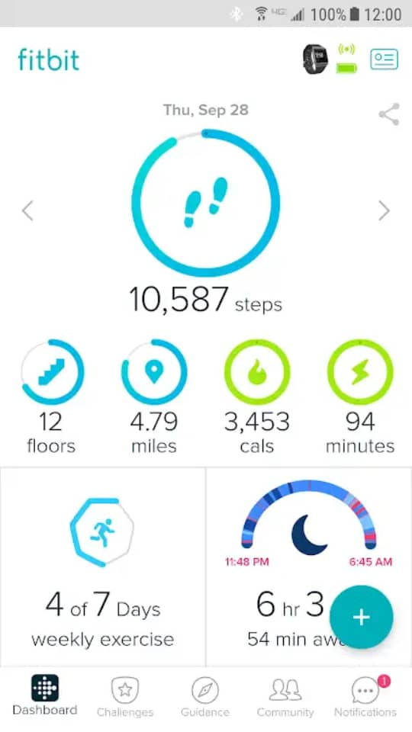Fitbit is a mobile application that developed by Fitbit inc. Fitbit is dedicated to help people to lead healthier and more active in their lives. Fitbit app is free to use and it is designed to work with smart scales and Fitbit activity tracker which is similar with smartwatch.

Figure 6 Home Page

Figure 6 shows the home page of the Fitbit application. The layout of this application is very tidy and neat as shown as Figure 6. This application contains bottom navigation which make user easier to know where they are now and easier go to other functionalities. User able to add activity to track by pressing the add button at the right corner. User also able to edit the activity added by long presses the activity icon.

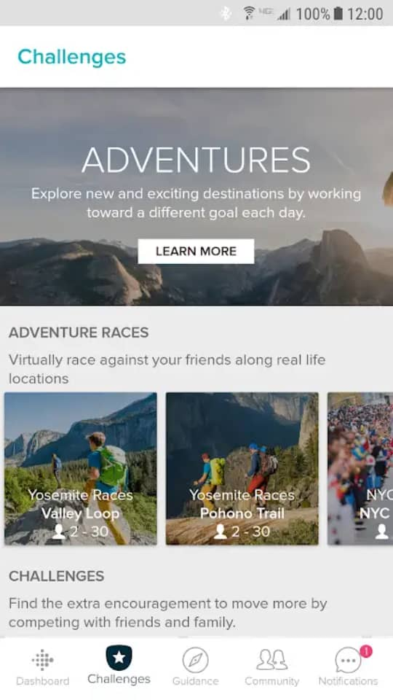

Figure 7 Challenges Page

Figure 7 shows the challenges page of this application. There are many challenges are displayed here. User is able to accept a challenge by press the icon. Different challenges have different requirements. User is needed to follow the rules to complete the challenges.

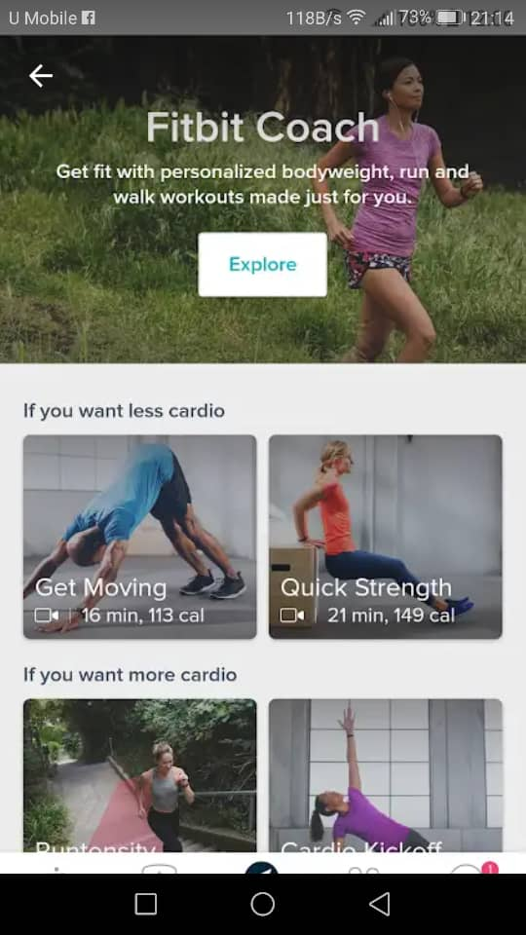

Figure 8 Guidance Page

Figure 8 shows the Guidance Page for this application. This page will provides a lot of efficient workout that help user to burn calories. The workout tutorial is shown in video. User need to download another application called ‘Fitbit Coach’ to proceed with the workout tutorial.

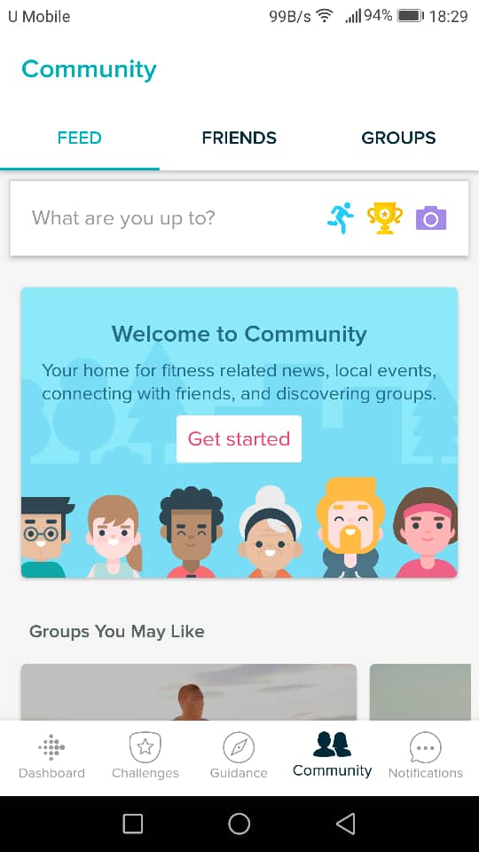

Figure 9 Community Page

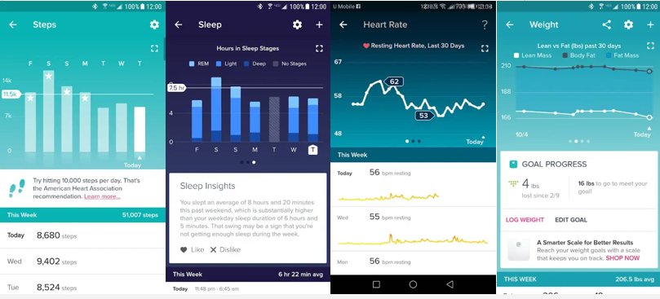Figure 9 shows the Community page of this application. With this functionality, user able to share experience and communicate with other like-minded people. User able to share their experience by taking photo and post it. Then, other person that same in the group can give comment on it.

Figure 10 Statistic for different category

Figure 10 shows the statistic for different category. The application will record the information every day and shows the statistic by using graph.

#### **2.2.2.1 Strengths and limitations of application**

|  |  |
| --- | --- |
| Strengths for this application | Limitations for this application |
| 1. Simple and neat GUI | 1. Voice recognition does not implemented in this application. |
| 2. User friendly application | 2. This application does not has functionality such as memo or reminder. |
| 3. Standard graph provided to show the statistic of user’s activity such as heart rate, step and others. | 3. Low Readability. Font size too small and hard to read. |
| 4. User able to share experience in this platform. |  |
| 5. Able to work with activity tracker(smartwatch) or smart scales. |  |

#### **2.2.2.2 Smartwatch**

This Fitbit application is designed to work with Fitbit activity scales and activity trackers which is the smartwatch. This application is wirelessly sync user activity trackers which is the smartwatch with the android device. The sync operation between android device and activity tracker is using Bluetooth. By wearing smartwatch, users able to track their daily goals and progress over time for steps, distance, calories burned, heart rate and others. Besides, GPS is implemented to track users’ runs, walks and hikes during their activities.

##### **2.2.2.2.1 Actigraphy**

Actigraphy is the method that using a device which is the smartwatch to track movements in order to measure sleep. It will monitors users’ movements when users is wearing the smartwatches. When users sync their device the next morning, the software will translates those movements into sleep data. If users are ever edited their sleep times the next morning, users will have seen a glimpse. The data about movements of the users during "awake" time gets re-analysed when users tell the software they were actually asleep and they see it charted as sleep data (Belle, 2014).

##### **2.2.2.2.2 Optical heart rate sensors**

Optical heart rate sensors are used to produce on-the-spot readings of heart rate data which can be a good indication of user current state of health. All of these hear rat monitors are based on the same technology which is the light-based optical tech (PPG). This technology uses flashing LEDs which penetrate the skin to detect blood flow. The light reflected off that blood flow is captured by those sensors and with algorithm smarts produce the heart rate data. It's a non-invasive way to measure heart rate (Sawh, 2018).

##### **2.2.2.2.3 Accelerometer**

Fitbit devices use a 3-axis accelerometer to understand users’ motions. An accelerometer is a device that turns movement (acceleration) into digital measurements (data) when attached to the body. By analysing acceleration data, Fitbit devices provide detailed information about frequency, duration, intensity, and patterns of movement to determine your steps taken and distance travelled. The 3-axis implementation allows the accelerometer to measure your motion in any way that you move, making its activity measurements more precise than older, single-axis pedometers (Fitbit, 2019).

##### **2.2.2.2.4 Calories Burned**

Fitbit devices estimate users’ calorie burn based on age, sex, height, and weight. If users’ devices measure heart rate, the calorie burn estimate also takes heart rate into account. The value that shown on Fitbit device when users wake up in the morning is estimated calorie burn for the day so far. Users still burn calories even if users are sedentary or sleeping (Fitbit, 2019).

### 2.2.3 Overview of “Senior Safety Phone”

Senior Safety Phone is an android application which helps users to transform their phone into an intuitive simple user friendly interface specifically formulated for anyone who has difficulty with using smartphone especially senior citizen.

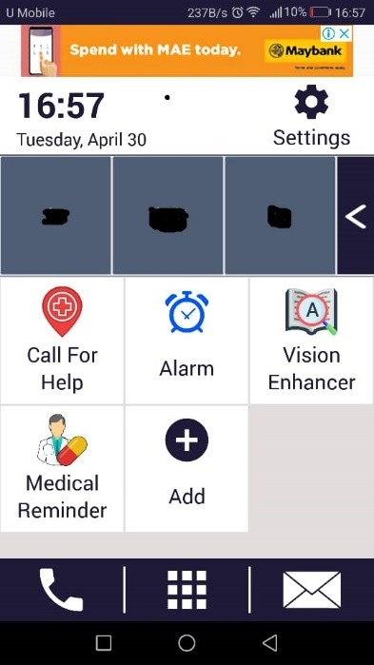

Figure 11 HomePage of Senior Safety Phone

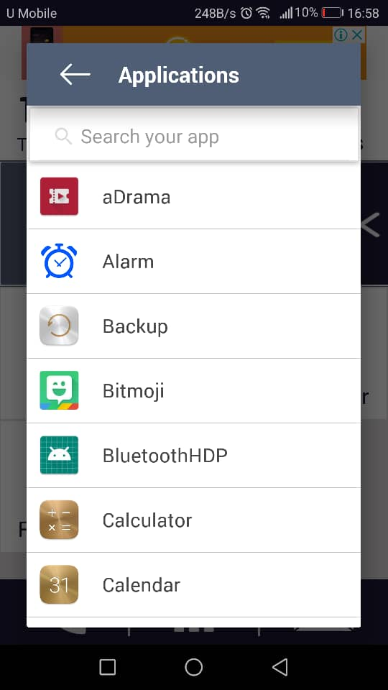

Figure 12 Add application

This application give a completely new look of interface as Figure 11. Large colourful buttons to help those shaky hands. Single touch access to the most frequently called contacts. Users able to design their own home screen by adding new application which they frequently use. After press the add button, a page will pop up as Figure 12 to let users choose their frequently use application.

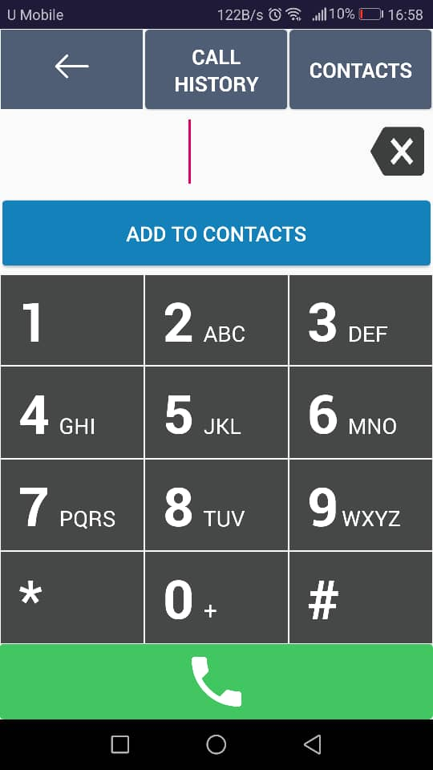

Figure 13 Dialler Page

Figure 13 shows the dialler page that provided by this application. The list of contact is connected with the list of contact in the phone. Figure 13 shows that the button of the dialler is much bigger than the normal to make users more convenience when dialling phone number.

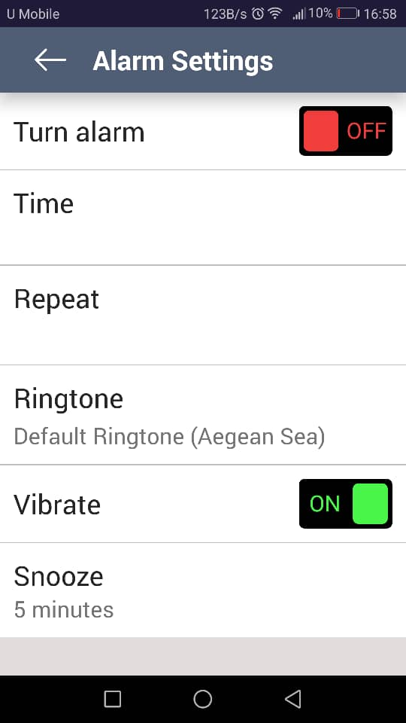

Figure 14 Alarm Settings

This application provides set alarm function as Figure 14. Users able to set their personal alarm based on the time set by themselves. This alarm consists of all basic functionality. However, user are not able to set the description of the alarm.

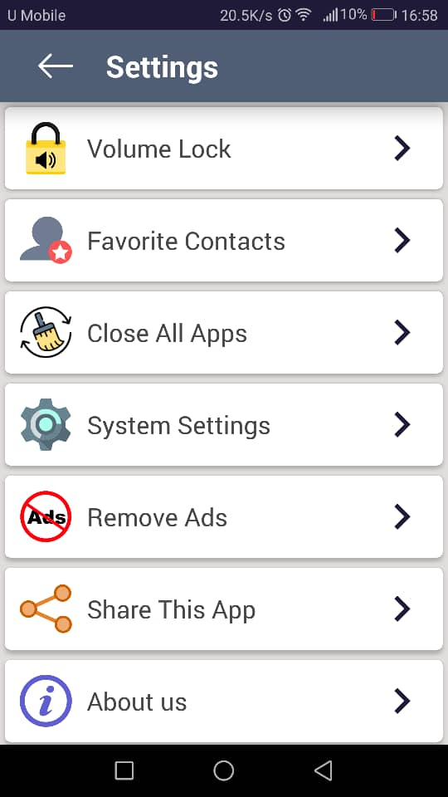

Figure 15 Advanced Settings

Figure 15 shows the advanced settings that provided in this application. These advanced settings are used to maximize the usability of this application.

#### **2.2.3.1 Strengths and limitations of application**

|  |  |
| --- | --- |
| Strengths for this application | Limitations for this application |
| 1. User friendly application | 1. Voice recognition does not implemented in this application. |
| 2. Maximize Readability | 2. This application does not has functionality to record user current health condition |
| 3. Make Calling Easier. One touch to make a phone call in favorite list. | 3. This application not able record note in type of text, audio or photo. |

New Ideas

This chapter discusses about the new ideas that is generated after surveying on the existing website. Some ideas is filtered and also enhanced to achieve a better quality website. New ideas are all listed in this chapter.

Introduction

As a result of your 'Limitations' chapter you should have narrowed down your area of research. This 'focussing' of attention on one aspect of the field will have been aided by reading about other peoples' work in the field. You may be proposing a development of one of their ideas or perhaps an idea that came to you that differs from anything tried before.

For a software development you might include an explicit list of the requirements, a description of investigation of requirements ( if appropriate), and a discussion of how requirements relate to Background research.

For a research-based investigation you might include the planning for the process (methodology) to be adopted, the criteria to be used for evaluation, and a discussion of reasons for this process and comparison with alternatives.

The proposed development or investigation must be realistic bearing in mind the entire project is supposed to take 400 hours of your time. Thus, evidence of project planning must be included in this chapter; estimates of work load for the various phases, setting these in context with other estimated workloads (e.g. course work and revision) and other deadlines. This should allow you to establish your project timetable (perhaps in the form of a Gantt chart) showing the interaction of these various factors and the set objectives/milestones. In your planning you should include contingency planning to allow for the unexpected disaster. Various project planning tools are covered in the course to allow you to do this.



IMPLEMENTATION or INVESTIGATION

Introduction

Here you give details of the development or investigation of the new material proposed in 'New Ideas'. This must be done in a business-like manner. The development of any software must follow a suitable analysis and design methodology. There are CASE tools available to you for some methodologies, others will have to be a 'paper' design. An investigation must also follow a suitable methodology and use appropriate techniques and tools.

Software-based projects, requiring the production of a software solution for a set of requirements, should demonstrate that the software development has undergone appropriate analysis, design, project management, structured programming and testing. Research-based projects, requiring an investigation of a research question or client’s requirements, or being used to test a hypothesis, should demonstrate that the investigation has been properly conducted, is based on scientific principles and uses appropriate tools, techniques and standards. An investigation must produce a technical outcome from some development (software or hardware (e.g. networks, displays)) or testing (e.g. of system/network performance, system security, HCI/usability analysis). Sometimes a software prototype or a testing framework will be produced for the evaluation or testing of the research or hypothesis. Work based purely on literature review is not acceptable.

Some projects aim to provide software for general use as their final product and these must include relevant aspects of HCI (Human Computer Interaction) and address such features of usability such as 'user friendliness' and most likely employ GUI (graphical user interface) standards such as Windows.

In any case, students often ask what should go in this chapter, how to describe what they have done, what is relevant, how much of existing work to include, what to include from what they have done, etc. The simplest and surest way is to refer to your diary of the work you have done and report on it in chronological order.

The complete requirements analysis, problem analysis & design of software must be done rigorously and included in full in an appendix. Avoid cross-referencing it too often, thus causing the reader to keep flicking pages back and forth, rather reproduce sections that you wish to draw the reader's attention to. That is, highlight the parts that you found particularly difficult to implement and feel rather proud of having solved. Do not include lengthy descriptions of standard techniques or methodologies, simply state that 'such-and-such was designed using such-and-such technique (give a reference, not just 'SSADM' but 'SSADM [James 1996]' where the reference is a standard text on the technique!)' and highlight where you found shortcomings in the technique that didn't quite cope with your particular problem. Highlight exceptions to the standard.



RESULTS / DISCUSSION

Introduction

The technique developed as your project is supposed to show improvement on techniques previously available. Therefore it may be necessary to spend time investigating whether this is true. Perhaps you need to set up some sort of quantitative test and do a little statistical analysis to confirm the improvement. Perhaps a group of your friends could test out the user interface and provide comment on its suitability for the task. Try to estimate the limitations of your work and if it does not cover certain aspects that a user might expect then say so and make sure the system will reject input it is not expected to cope with.



CONCLUSIONS / FUTURE WORK

## Introduction

Whatever it was that your results showed should be summarised here. Hopefully the conclusion will be that your proposals proved to be brilliant and now the results bear this out. On the other hand your proposals may, in the light of the results obtained, prove to be less successful than you had hoped. In this case the conclusions should state why.

In either case there should be some reference to future work, either to forward and expand on the successful outcome or to test ways of overcoming the shortfall in your ideas that didn't work out quite as expected but there should be something that shows you can see further implications of what you have achieved.

ReferenceS

Vogt, C. 1999. Creating Long Documents using Microsoft Word. Published on the Web at the Nottingham Trent University.

**Note:** References are a list that includes the essential bibliographical details for each item to which you have referred in the body of your paper. It should ONLY include items to which you have made direct reference. A direct reference is where you have quoted/reproduced text or diagrams from another author or mentioned/referred to the work of another author in your report. That is quoted directly what they have said about something or mentioned their views or conclusions in your report. For details of citation and references see the information in the Project Guide.

A Bibliography is a list of published materials that you have read or consulted for general information in the preparation of your work, concerning the subject of your Project, but have not made any direct reference to in your report i.e. 'background reading'.

You should always provide a Reference List. **A Bibliography is optional but when provided it should include all items in your Reference List as well as any additional items consulted in preparation of your work.**

Bibliography

Vogt, C. 1999. Creating Long Documents using Microsoft Word. Published on the Web at the Nottingham Trent University.

Coote, H., Dobbs, B. & Jones, C. (1996). Defining databases. Wiley: Melbourne.

Applications and Science in Soft Computing, Lotfi, Ahmad; Garibaldi, Jonathon M. (Eds.) 2004, X, 346 p. Springer, ISBN: 3-540-40856-8

**Note:** References are a list that includes the essential bibliographical details for each item to which you have referred in the body of your paper. It should ONLY include items to which you have made direct reference. A direct reference is where you have quoted/reproduced text or diagrams from another author or mentioned/referred to the work of another author in your report. That is quoted directly what they have said about something or mentioned their views or conclusions in your report. For details of citation and references see the information in the Project Guide.

A Bibliography is a list of published materials that you have read or consulted for general information in the preparation of your work, concerning the subject of your Project, but have not made any direct reference to in your report i.e. 'background reading'.

You should always provide a Reference List. **A Bibliography is optional but when provided it should include all items in your Reference List as well as any additional items consulted in preparation of your work.**

Appendix A

The content of these will differ with the different types of project. Any design and analysis charts/diagrams will be included here in full. In projects where software has been developed there will be an appendix for this. Our departmental requirement is that a CD, DVD or USB memory stick of all source code is submitted to your project supervisor. The appendix contained in the report will refer to this CD, DVD, or USB memory stick, provide a directory style listing of the files submitted and instructions for rebuilding and running the software. This might be source code of programs written in high level languages (C, C++, etc) together with any pertinent files ('make' files, non-standard libraries, etc). Alternatively, or in addition, you can place some or all of the source code in the appendix. In any case the source code needed to reconstruct any software you have developed must be submitted in its entirety in the CD, DVD, or USB memory stick. (Any code that has been used from a third party should reference the original developer).

Hardware designs will require schematics/circuit diagrams, PCB layouts, simulation tests and pin outs.

Most projects will require some form of user documentation to explain how to use the software/hardware produced. A researcher following up the work may wish to utilise the work of the original author and an appendix laying out the format of input files and how to interpret the output is required.